Assignment 1

1. Basic Software Prerequisites:

1. Download the latest release of Spark ( Spark 1.4 )with Hadoop libraries:

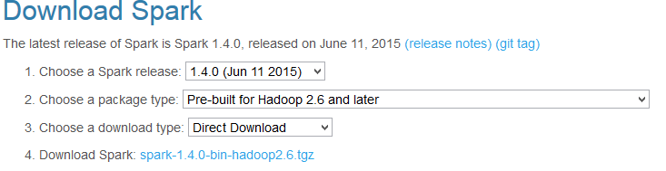

1. Extract the zip in the C: folder
2. Download the **winutils.exe** file from the internet and place it in the **C:\spark-1.4.0-bin-hadoop2.6\bin**
3. Set the following variable in the Env path :

SPARK_HOME = C:\spark-1.4.0-bin-hadoop2.6

HADDOOP_HOME = %SPARK_HOME%

PATH=%SPARK_HOME%/bin

1. Check if the SPARK is working properly :

Go to CMD or Cygwin (if you installed) and run the following command it will open the Spark environment:

**C:\spark-1.4.0-bin-hadoop2.6\bin>spark-shell**

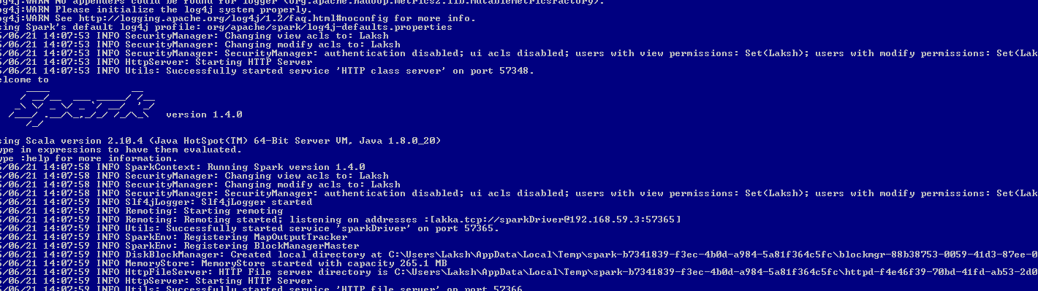

2. Scala:

**Software Prerequisites:**

1. Download Java 8 and Install and set the JAVA_HOME path in the environment variable.
2. Install Maven Plugins in eclipse from Eclipse Market place.
3. Download Eclipse and Install Scala plugins from Eclipse Market Place:

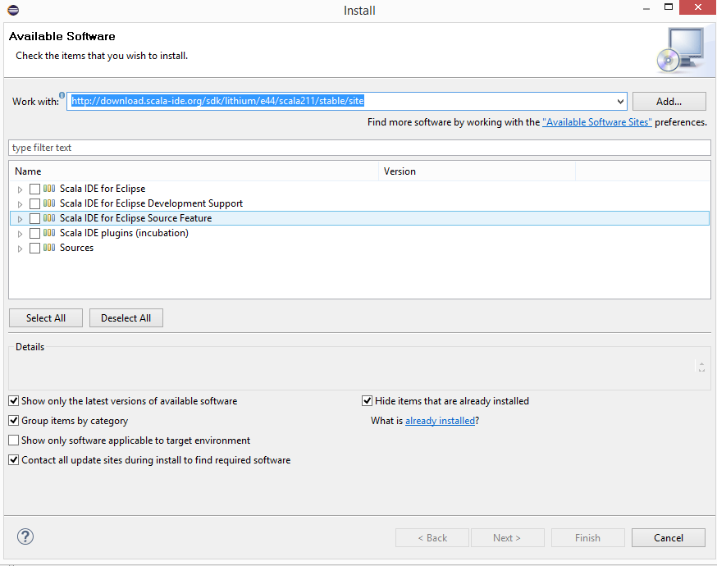

1. Create New Maven Project from the Eclipse (See below Screenshot)

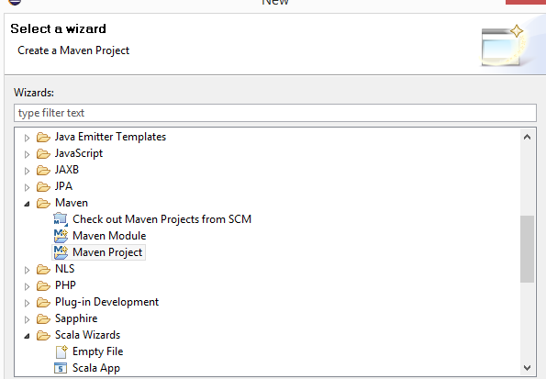

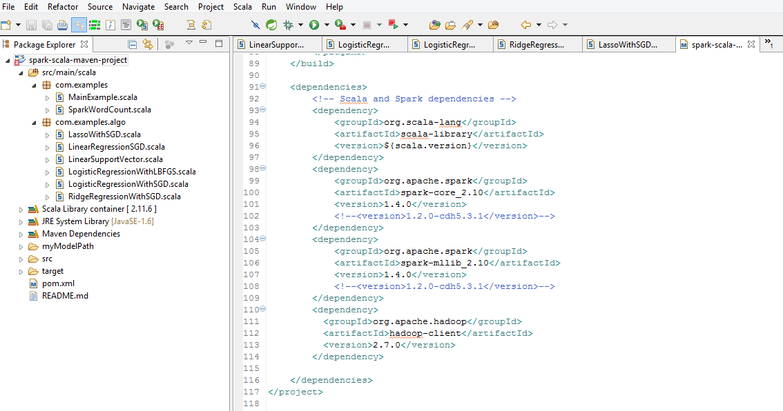

1. Install the below dependencies in the POM.xml file in the **spark-scala-maven-project**

<project xmlns=*"http://maven.apache.org/POM/4.0.0"* xmlns:xsi=*"http://www.w3.org/2001/XMLSchema-instance"*

xsi:schemaLocation=*"http://maven.apache.org/POM/4.0.0 http://maven.apache.org/maven-v4_0_0.xsd"*>

<modelVersion>4.0.0</modelVersion>

<groupId>spark-scala-maven-project</groupId>

<artifactId>spark-scala-maven-project</artifactId>

<version>0.0.1-SNAPSHOT</version>

<name>${project.artifactId}</name>

<description>This is a boilerplate maven project to start using Spark in Scala</description>

<inceptionYear>2010</inceptionYear>

<properties>

<maven.compiler.source>1.6</maven.compiler.source>

<maven.compiler.target>1.6</maven.compiler.target>

<encoding>UTF-8</encoding>

<scala.tools.version>2.10</scala.tools.version>

<!-- Put the Scala version of the cluster -->

<scala.version>2.10.4</scala.version>

</properties>

<!-- repository to add org.apache.spark -->

<repositories>

<repository>

<id>cloudera-repo-releases</id>

<url>https://repository.cloudera.com/artifactory/repo/</url>

</repository>

</repositories>

<build>

<sourceDirectory>src/main/scala</sourceDirectory>

<testSourceDirectory>src/test/scala</testSourceDirectory>

<plugins>

<plugin>

<!-- see http://davidb.github.com/scala-maven-plugin -->

<groupId>net.alchim31.maven</groupId>

<artifactId>scala-maven-plugin</artifactId>

<version>3.1.3</version>

<executions>

<execution>

<goals>

<goal>compile</goal>

<goal>testCompile</goal>

</goals>

<configuration>

<args>

<arg>-make:transitive</arg>

<arg>-dependencyfile</arg>

<arg>${project.build.directory}/.scala_dependencies</arg>

</args>

</configuration>

</execution>

</executions>

</plugin>

<plugin>

<groupId>org.apache.maven.plugins</groupId>

<artifactId>maven-surefire-plugin</artifactId>

<version>2.13</version>

<configuration>

<useFile>false</useFile>

<disableXmlReport>true</disableXmlReport>

<!-- If you have classpath issue like NoDefClassError,... -->

<!-- useManifestOnlyJar>false</useManifestOnlyJar -->

<includes>

<include>**/*Test.*</include>

<include>**/*Suite.*</include>

</includes>

</configuration>

</plugin>

<!-- "package" command plugin -->

<plugin>

<artifactId>maven-assembly-plugin</artifactId>

<version>2.4.1</version>

<configuration>

<descriptorRefs>

<descriptorRef>jar-with-dependencies</descriptorRef>

</descriptorRefs>

</configuration>

<executions>

<execution>

<id>make-assembly</id>

<phase>package</phase>

<goals>

<goal>single</goal>

</goals>

</execution>

</executions>

</plugin>

</plugins>

</build>

<dependencies>

<!-- Scala and Spark dependencies -->

<dependency>

<groupId>org.scala-lang</groupId>

<artifactId>scala-library</artifactId>

<version>${scala.version}</version>

</dependency>

<dependency>

<groupId>org.apache.spark</groupId>

<artifactId>spark-core_2.10</artifactId>

<version>1.4.0</version>

<!--<version>1.2.0-cdh5.3.1</version>-->

</dependency>

<dependency>

<groupId>org.apache.spark</groupId>

<artifactId>spark-mllib_2.10</artifactId>

<version>1.4.0</version>

<!--<version>1.2.0-cdh5.3.1</version>-->

</dependency>

<dependency>

<groupId>org.apache.hadoop</groupId>

<artifactId>hadoop-client</artifactId>

<version>2.7.0</version>

</dependency>

</dependencies>

</project>

1. Right Click on the Project and Run ***Maven Clean***

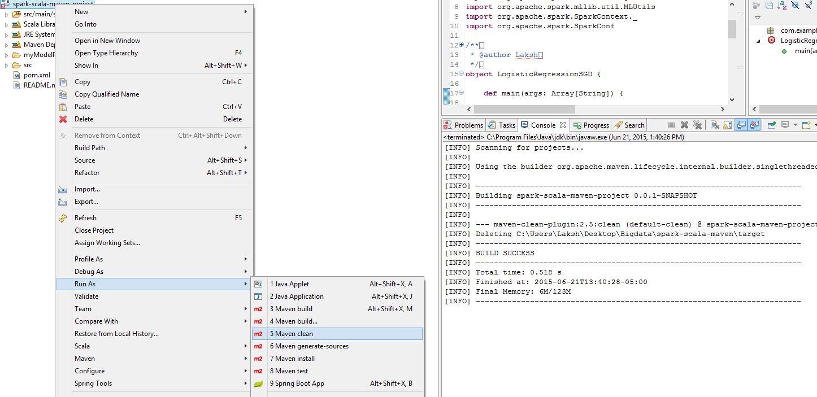

1. Right click and Run Maven Install, It will create the jar in the target folder of the project location

: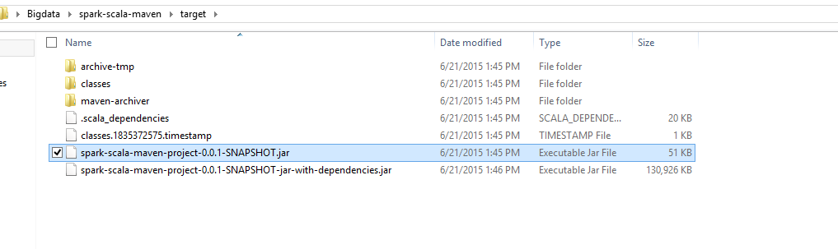

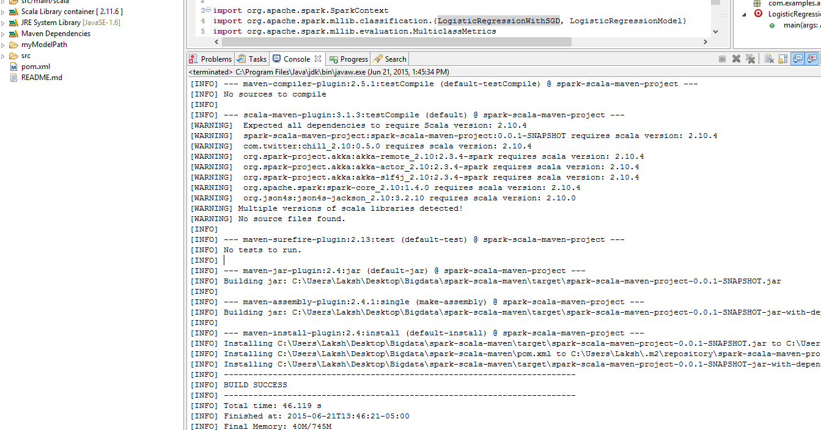

Running SCALA Algorithms:

SPARK RUN TIME COMMAND

L2

C:/spark-1.4.0-bin-hadoop2.6/bin/spark-submit --class "com.examples.algo.LinearSupportVector" --master local[1] target/spark-scala-maven-project-0.0.1-SNAPSHOT.jar

AreaUnderCurve.scala:45, took 0.097492 s

Area under ROC = 0.6327268553062039

L1

C:/spark-1.4.0-bin-hadoop2.6/bin/spark-submit --class "com.examples.algo.LinearSupportVectorL1" --master local[1] target/spark-scala-maven-project-0.0.1-SNAPSHOT.jar

AreaUnderCurve.scala:45, took 0.120979 s

Area under ROC = 0.6346782988004352

L2

C:/spark-1.4.0-bin-hadoop2.6/bin/spark-submit --class "com.examples.algo.LogisticRegressionLBFGS" --master local[1] target/spark-scala-maven-project-0.0.1-SNAPSHOT.jar

countByValue at MulticlassMetrics.scala:44, took 0.318731 s

Precision = 0.9605809128630706

L1

C:/spark-1.4.0-bin-hadoop2.6/bin/spark-submit --class "com.examples.algo.LogisticRegressionLBFGSL1" --master local[1] target/spark-scala-maven-project-0.0.1-SNAPSHOT.jar

countByValue at MulticlassMetrics.scala:44, took 0.272651 s

Precision = 0.9605809128630706

L2

C:/spark-1.4.0-bin-hadoop2.6/bin/spark-submit --class "com.examples.algo.LogisticRegressionLBFGS" --master local[1] target/spark-scala-maven-project-0.0.1-SNAPSHOT.jar

countByValue at MulticlassMetrics.scala:44, took 0.288646 s

Precision = 0.9605809128630706

L1

C:/spark-1.4.0-bin-hadoop2.6/bin/spark-submit --class "com.examples.algo.LogisticRegressionLBFGSL1" --master local[1] target/spark-scala-maven-project-0.0.1-SNAPSHOT.jar

countByValue at MulticlassMetrics.scala:44, took 0.349361 s

Precision = 0.9605809128630706

L2

C:/spark-1.4.0-bin-hadoop2.6/bin/spark-submit --class "com.examples.algo.LogisticRegressionSGD" --master local[1] target/spark-scala-maven-project-0.0.1-SNAPSHOT.jar

countByValue at MulticlassMetrics.scala:44, took 0.351778 s

Precision = 0.9600622406639004

L1

C:/spark-1.4.0-bin-hadoop2.6/bin/spark-submit --class "com.examples.algo.LogisticRegressionSGDL1" --master local[1] target/spark-scala-maven-project-0.0.1-SNAPSHOT.jar

countByValue at MulticlassMetrics.scala:44, took 0.350728 s

Precision = 0.9600631403650002

NO RegType

C:/spark-1.4.0-bin-hadoop2.6/bin/spark-submit --class "com.examples.algo.LinearRegressionSGD" --master local[1] target/spark-scala-maven-project-0.0.1-SNAPSHOT.jar

LinearRegressionSGD.scala:38, took 0.104092 s

training Mean Squared Error = 6.751135104498063E51

L2

C:/spark-1.4.0-bin-hadoop2.6/bin/spark-submit --class "com.examples.algo.RidgeRegressionSGD" --master local[1] target/spark-scala-maven-project-0.0.1-SNAPSHOT.jar

mean at RidgeRegressionWithSGD.scala:39, took 0.090872 s

training Mean Squared Error = 4.8042799175778876E51

L1

C:/spark-1.4.0-bin-hadoop2.6/bin/spark-submit --class "com.examples.algo.LassoSGD" --master local[1] target/spark-scala-maven-project-0.0.1-SNAPSHOT.jar

mean at LassoWithSGD.scala:39, took 0.062116 s

training Mean Squared Error = 1.4362289499005352E52

General Matrics for Scala

|  |  |  |  |
| --- | --- | --- | --- |
|  | Algorithms | L1 | L2 |
| Classification | SVMWithSGD | Area under ROC = 0.6346782988004352 | Area under ROC = 0.6327268553062039 |
| LogisticRegressionWithLBFGS | Precision = 0.9605809128630706 | Precision = 0.9605809128630706 |
| LogisticRegressionWithSGD | Precision = 0.9600631403650002 | Precision = 0.9600622406639004 |
| Regression | LinearRegressionWithSGD | (NA)  training Mean Squared Error = 6.75113510449806385 | |
| RidgeRegressionWithSGD | NA | training Mean Squared Error = 4.8042799175778876951 |
| LassoWithSGD | training Mean Squared Error = 1.4362289499005352952 | NA |

3. PySpark:

1. Create the ipython profile using pyspark with below command:

**ipython profile create pyspark**

1. It will create the below directory :

**C:\Users\Laksh\.ipython\profile_pyspark**

1. Edit the file **/.ipython/profile_pyspark/ipython_notebook_config.py and add following :**

c = get_config()

c.NotebookApp.ip = '*'

c.NotebookApp.open_browser = False

c.NotebookApp.port = 8880 # or whatever you want; be aware of conflicts with CDH

1. Create the file : C:\Users\Laksh\.ipython\profile_pyspark\startup\ ipython_notebook_config.py and edit the file :

import os

import sys

# Configure the environment

if 'SPARK_HOME' not in os.environ:

os.environ['SPARK_HOME'] = 'C:/spark-1.4.0-bin-hadoop2.6'

# Create a variable for our root path

SPARK_HOME = os.environ['SPARK_HOME']

# Add the PySpark/py4j to the Python Path

sys.path.insert(0, os.path.join(SPARK_HOME, "python", "build"))

sys.path.insert(0, os.path.join(SPARK_HOME, "python"))

sys.path.insert(0, os.path.join(SPARK_HOME, 'python/lib/py4j-0.8.1-src.zip'))

execfile(os.path.join(SPARK_HOME, 'python/pyspark/shell.py'))

1. Now the ipython notebook is ready and got command promt and open the notebook with below commands:

**ipython notebook --profile=pyspark**

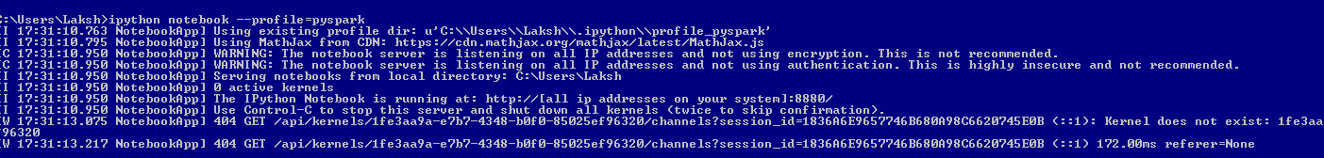

1. Go to browser : [**http://localhost:8880/tree**](http://localhost:8880/tree)

Click new and ipython notebook , it will open the another tab with ipython notebook.

1. Run the sc (SparkContext command) it will give the below result

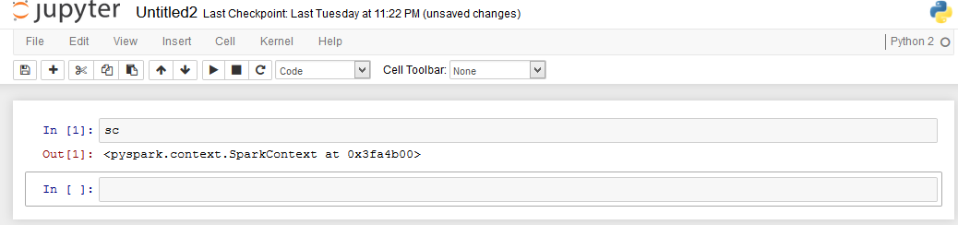

1. Run the code.

**Running Algorithms in Pyspark:**

Running L1 with **SVMWithSGD:**

**Various Parameter : iterations=100, regType='l1' ,step=.001**

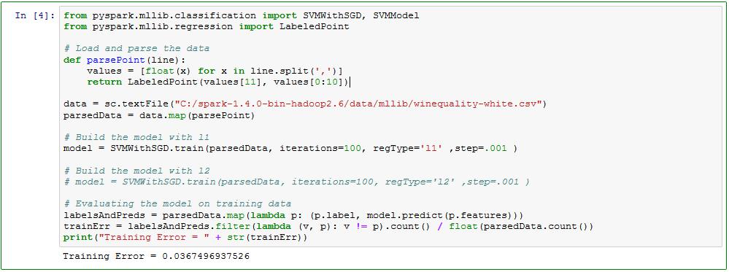

Running L2 with **SVMWithSGD:**

**Various Parameter: iterations=100, regType='l2' ,step=.001**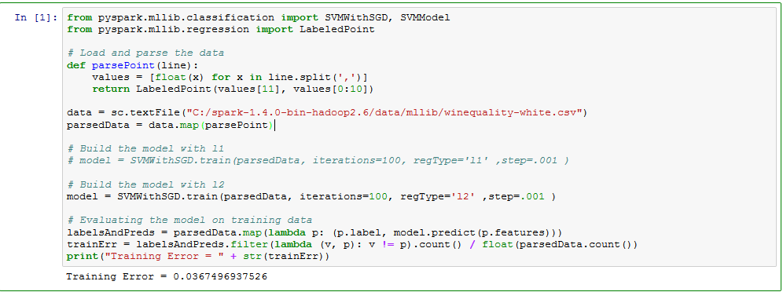

Running L1 with LogisticRegressionWithLBFGS:

**Various Parameter : iterations=100, regType='l1'**

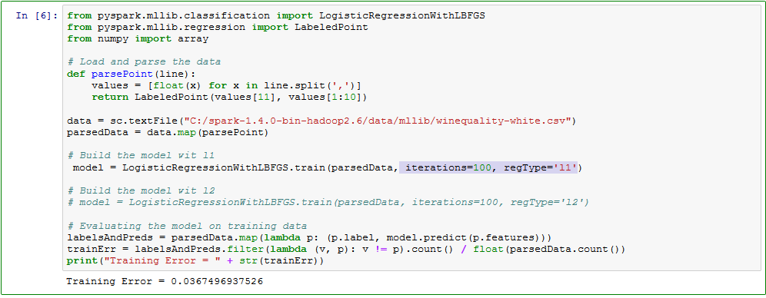

Running L1 with LogisticRegressionWithLBFGS:

**Various Parameter : iterations=100, regType='l2'**

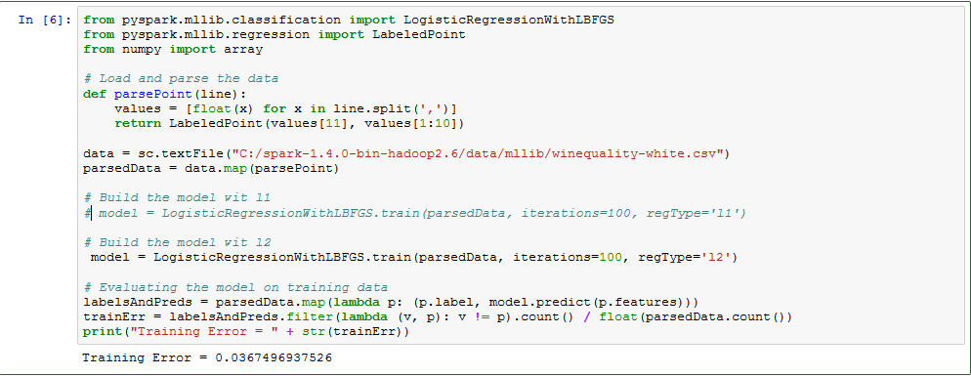

**Running L1 with LogisticRegressionWithSGD**

**Various Parameter : iterations=100, regType='l1'**

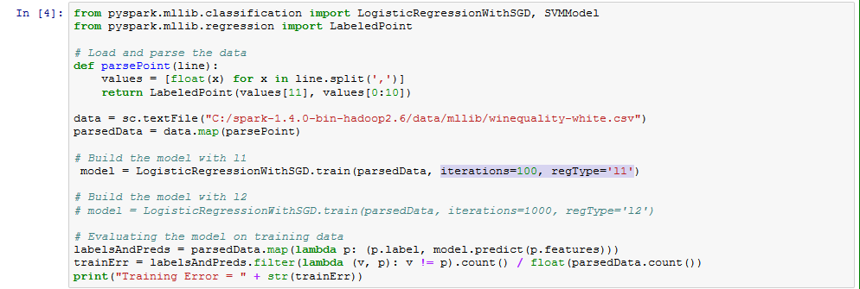

**Running L2 with LogisticRegressionWithSGD**

**Various Parameter: iterations=100, regType='l2'**

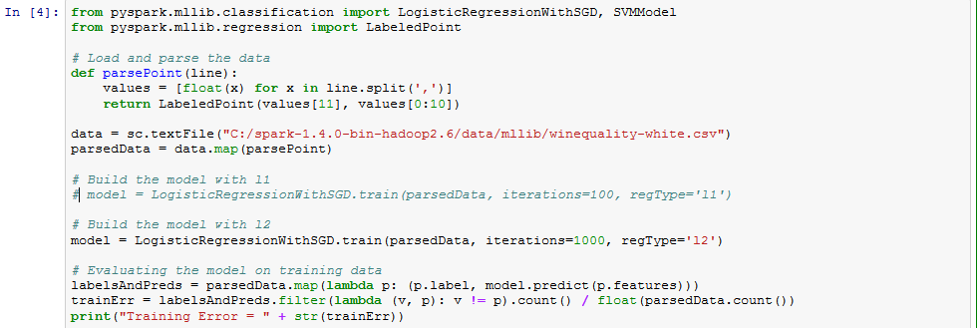

**Running LinearRegressionWithSGD:**

**Various Parameter: iterations=100, stepSize='.001'**

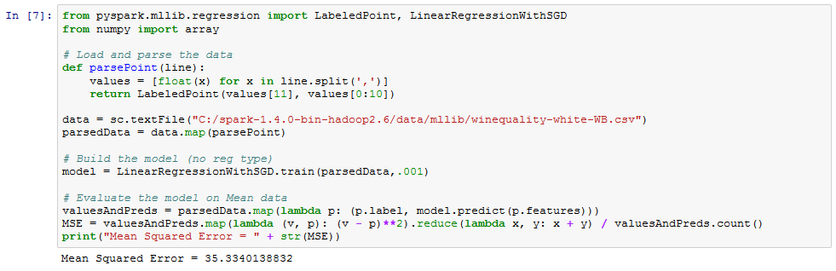

**Running RidgeRegressionWithSGD:**

**Various Parameter: iterations=100, stepSize='.001'**

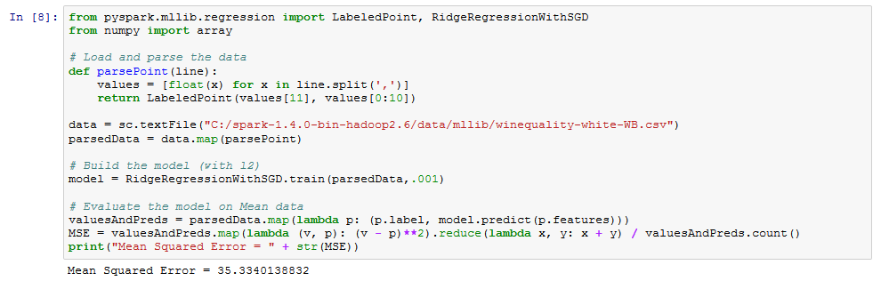

**Running LassoWithSGD**

**Various Parameter: iterations=100, stepSize='.001'**

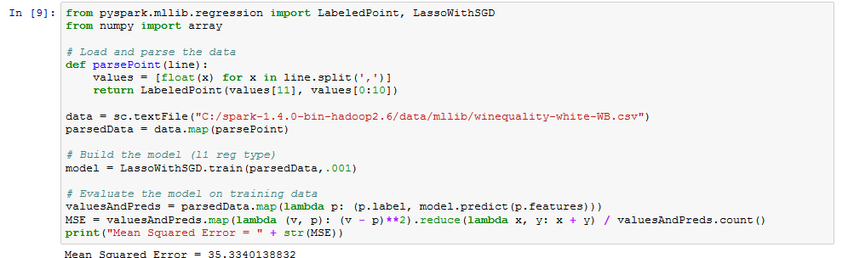

General Matrics for PySpark

|  |  |  |  |
| --- | --- | --- | --- |
|  | Algorithms | L1 | L2 |
| Classification | SVMWithSGD | Training Error = 0.0367496937526 | Training Error = 0.0367496937526 |
| LogisticRegressionWithLBFGS | Training Error = 0.0367496937526 | Training Error = 0.0367496937526 |
| LogisticRegressionWithSGD | Training Error = 0.0367496937526 | Training Error = 0.0367496937526 |
| Regression | LinearRegressionWithSGD | (NA)  Mean Squared Error = 35.3340138832 | |
| RidgeRegressionWithSGD | NA | Mean Squared Error = 35.3340138832 |
| LassoWithSGD | Mean Squared Error = 35.3340138832 | NA |

4. In Plain Python

1. Setting up anaconda and python
2. Installed anaconda for windows 8.1 using <http://continuum.io/downloads> for 64-Bit
3. Installed version for anaconda is 2.2.0 and for python should be 2.7.9. Higher version can also be installed as per the requirements.
4. set Anaconda in the environment path variable

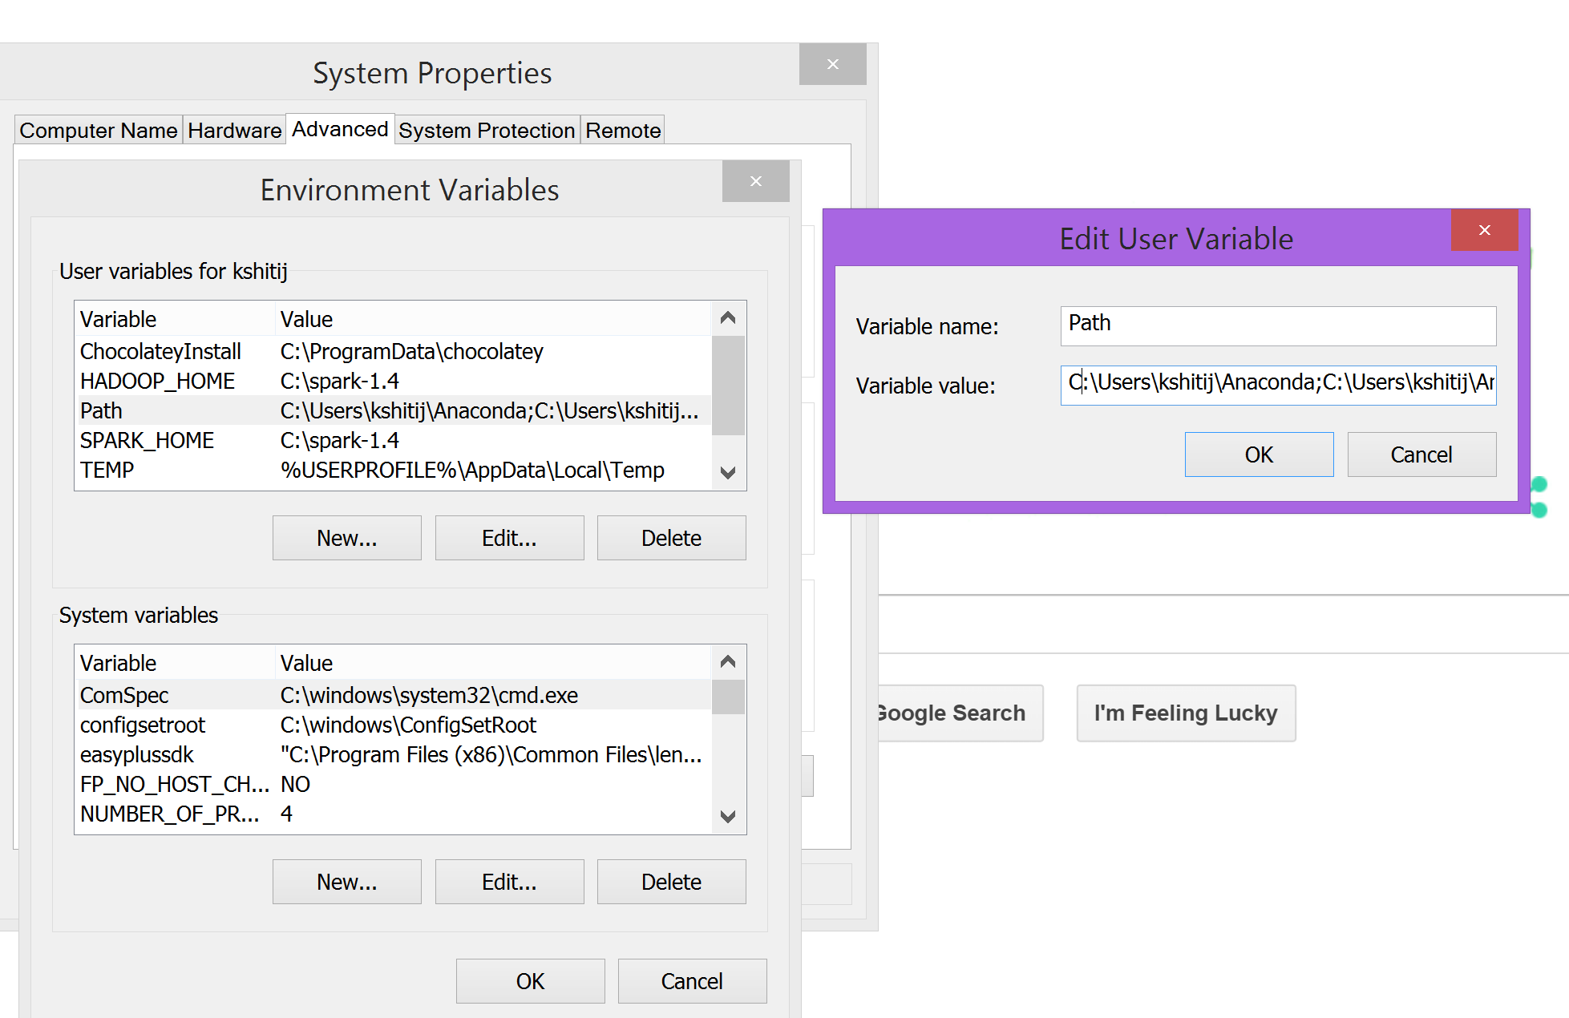

1. Updated numpy and scipy libraries using commands on anaconda command prompt
   1. conda update scipy and conda update numpy

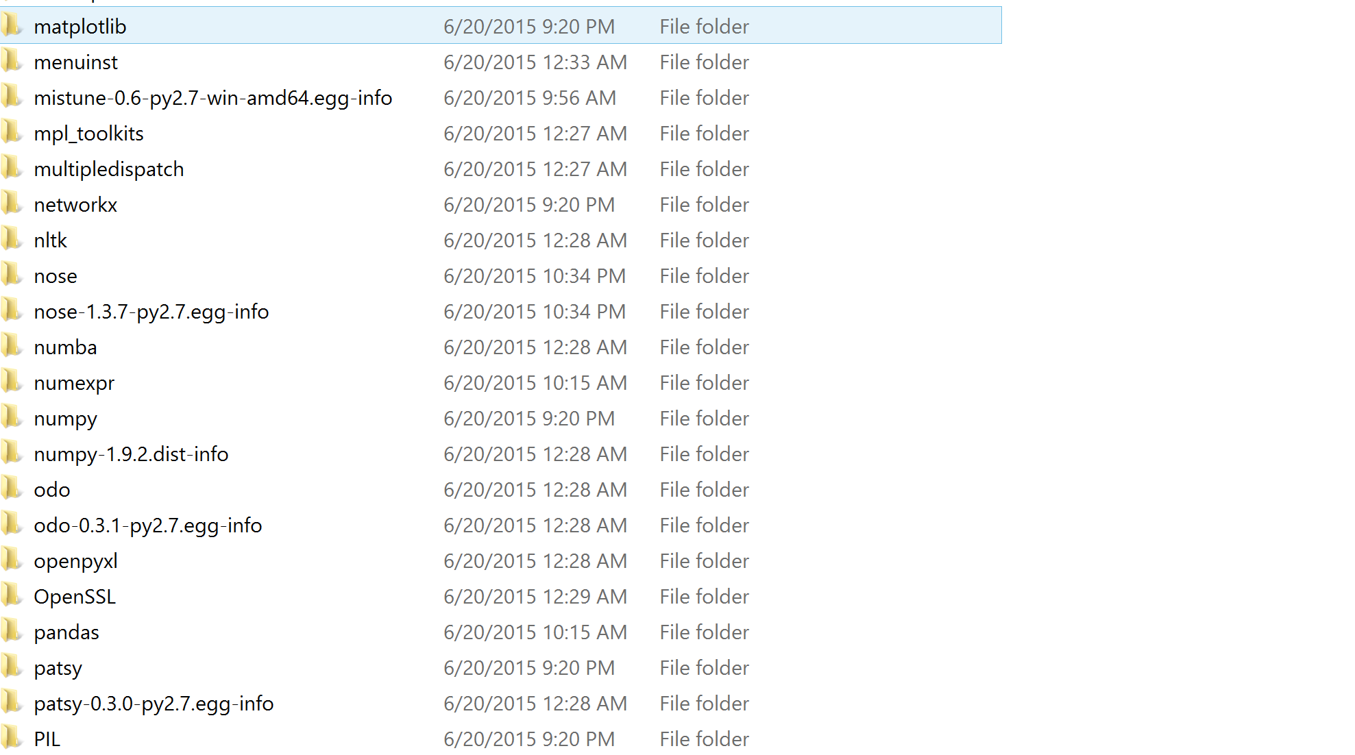

1. Run Python IDE SPYDER using anaconda command prompt

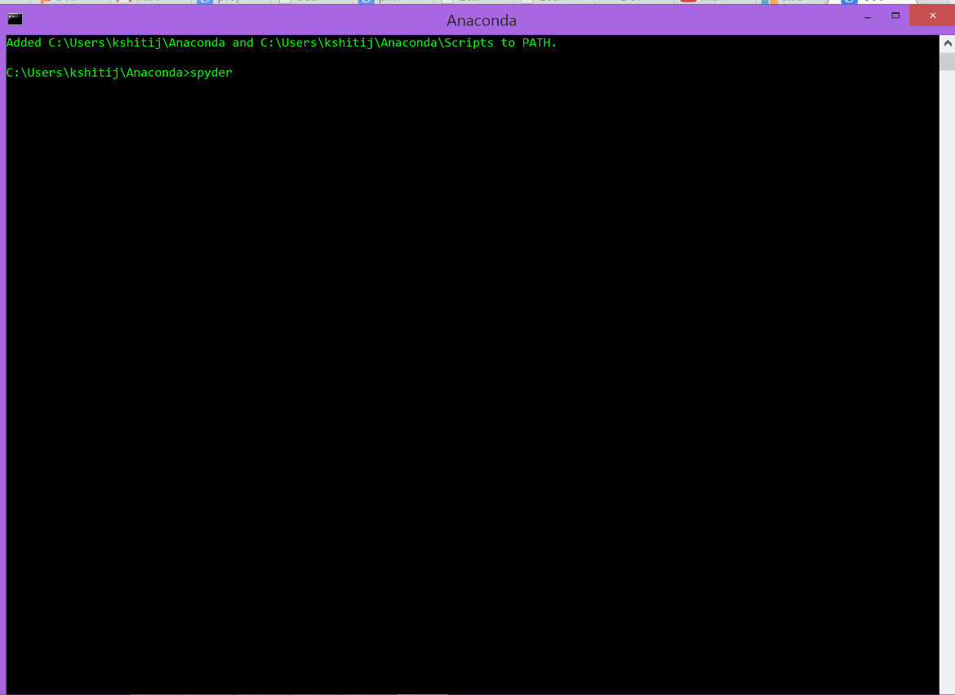

1. SPYDER IDE

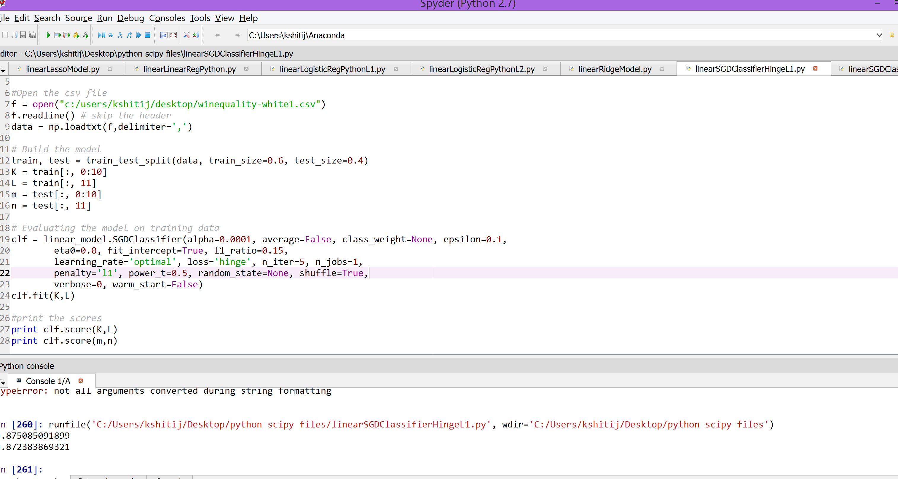

1. Writing algorithms
   1. Classification Models
2. Linear SGD Classifier – Hinge Loss - Used L1 regularizes and Hinge Loss function

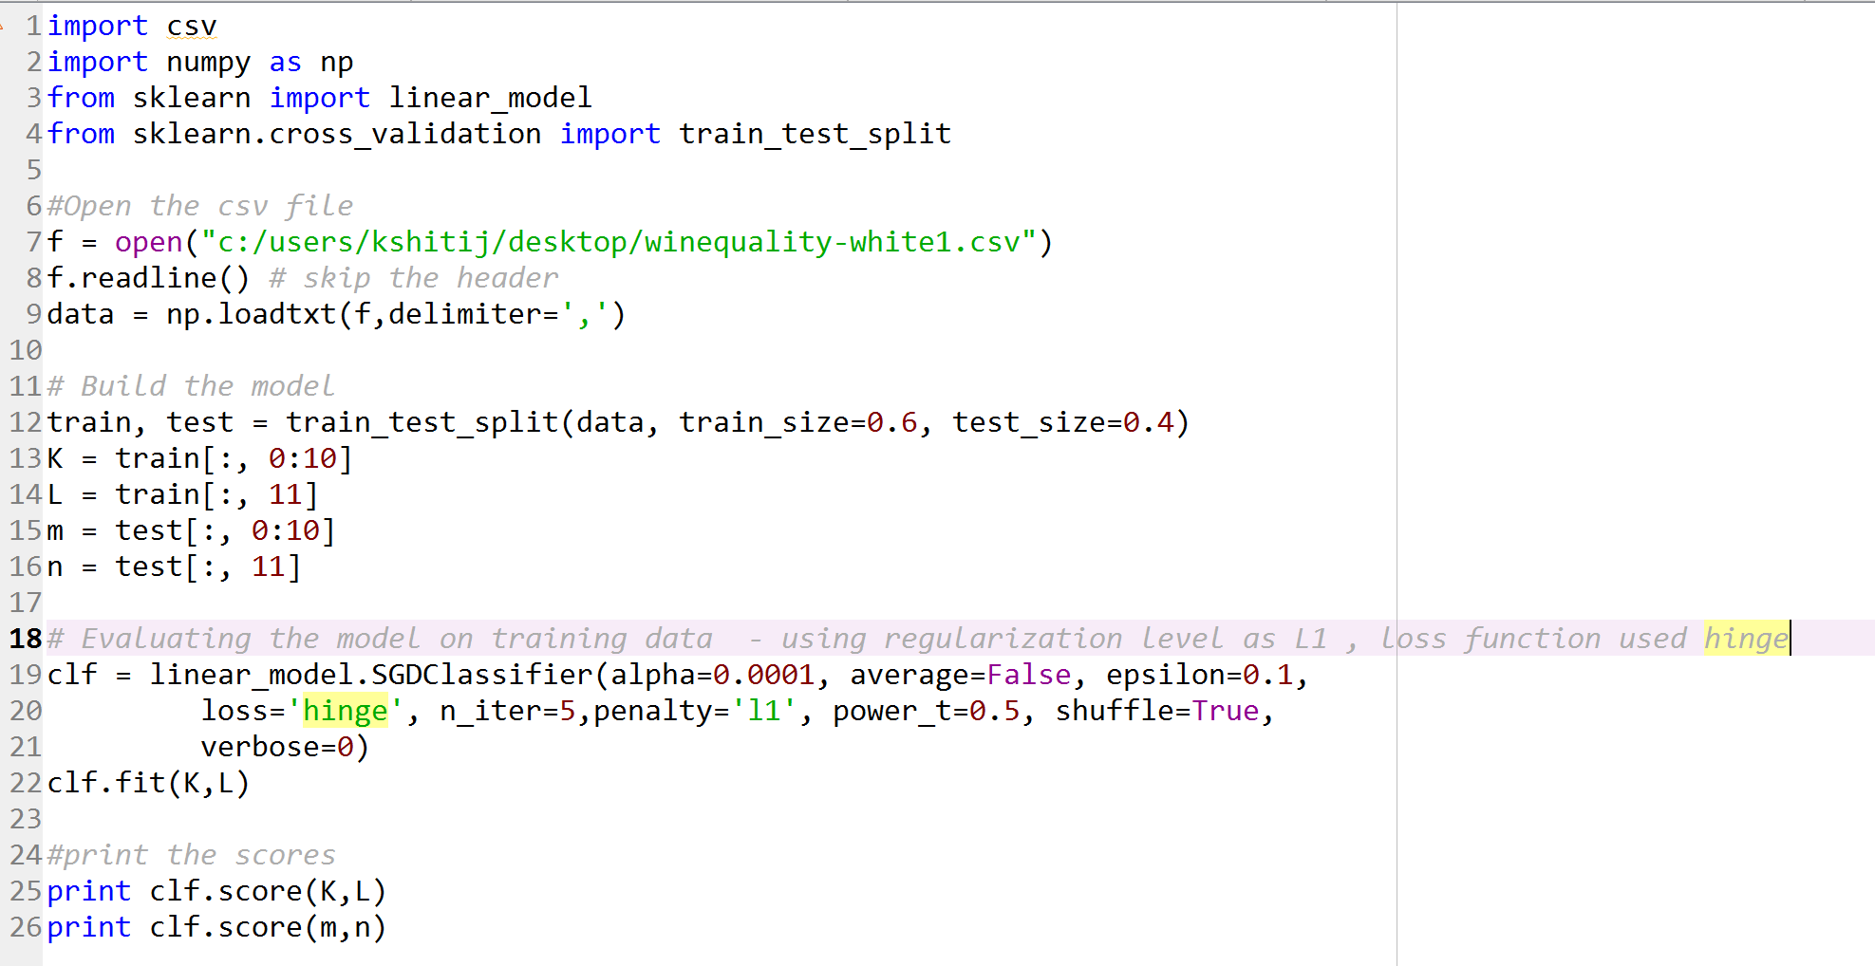

ii) Linear SGD Classifier – Hinge Loss - Used L1 regularizes and Hinge Loss function

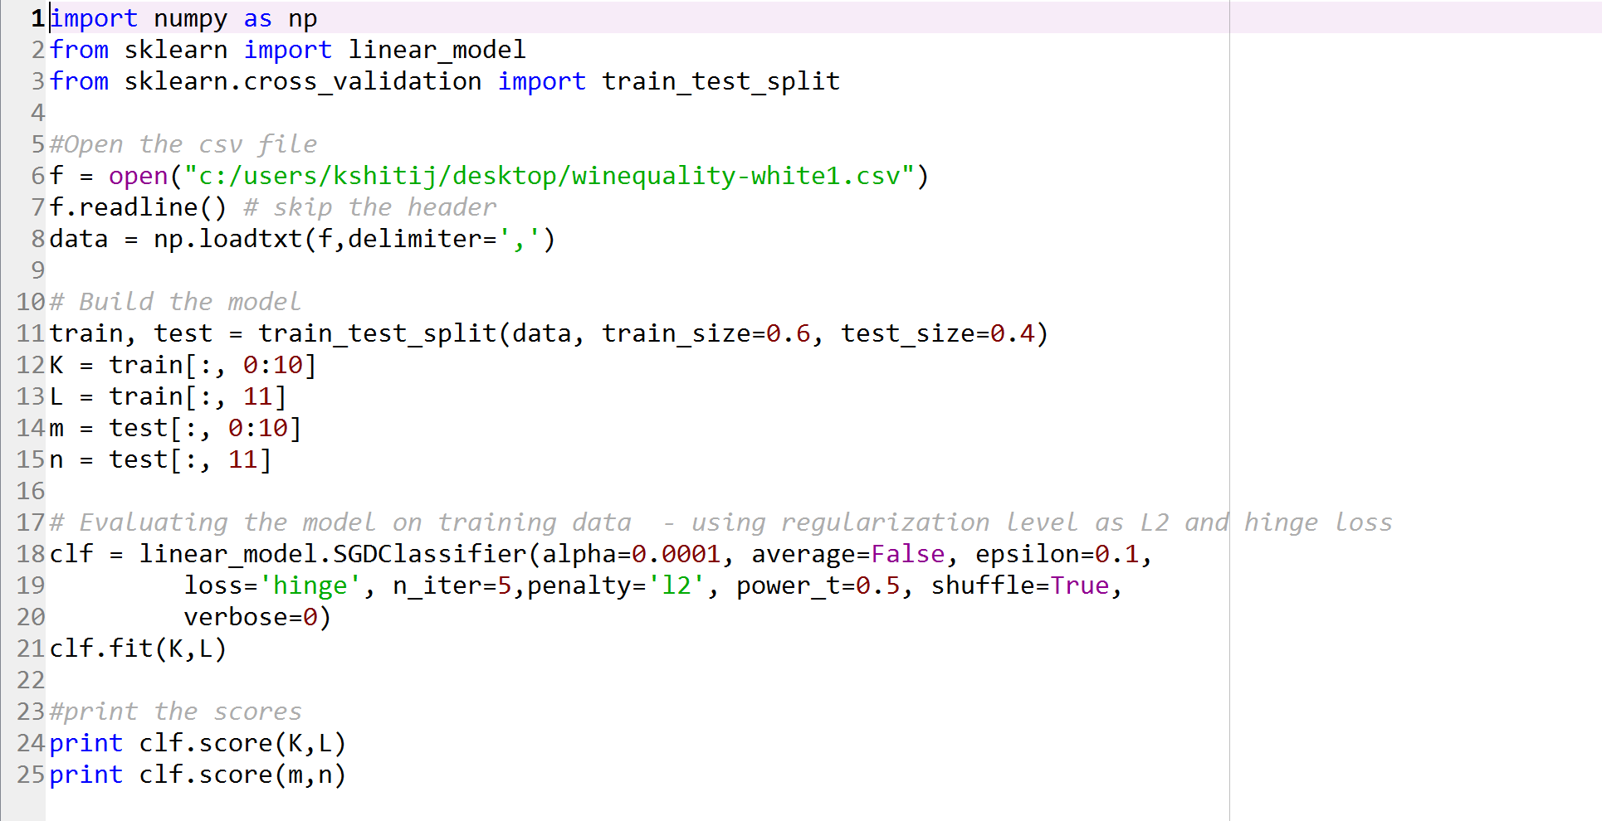

iii) Linear SGD Classifier – Log Loss - Used L1 regularizes and Log Loss function

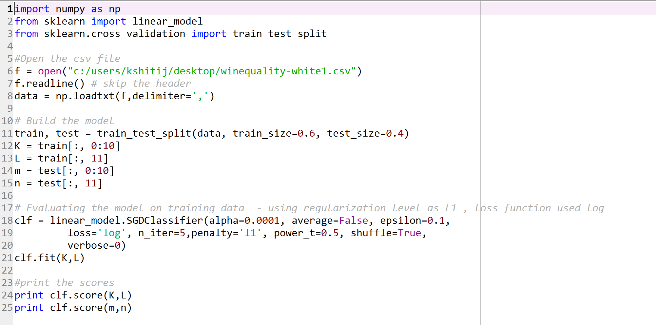

iv) Linear SGD Classifier – Log Loss - Used L2 regularizes and Log Loss function

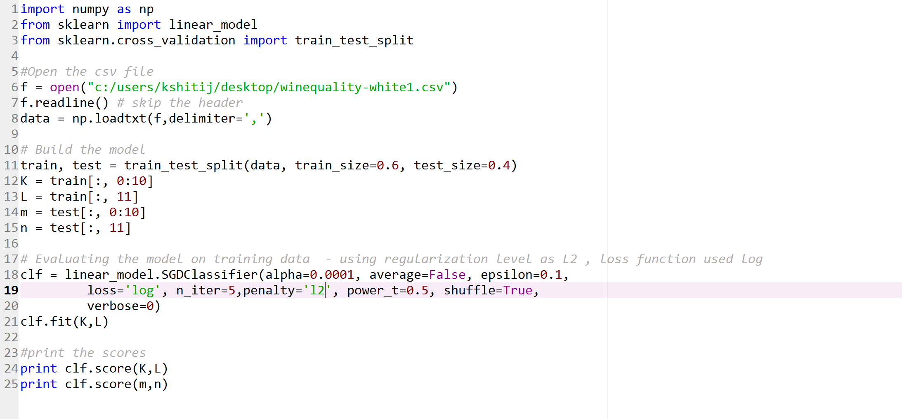

v) Logistic Regression Classification – L1 regularization

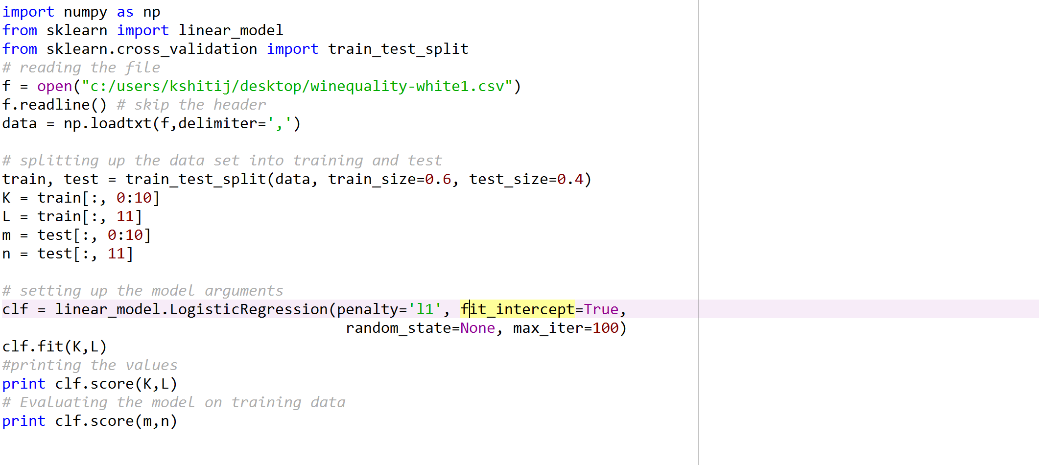

vi) Logistic Regression Classification – L2 regularization

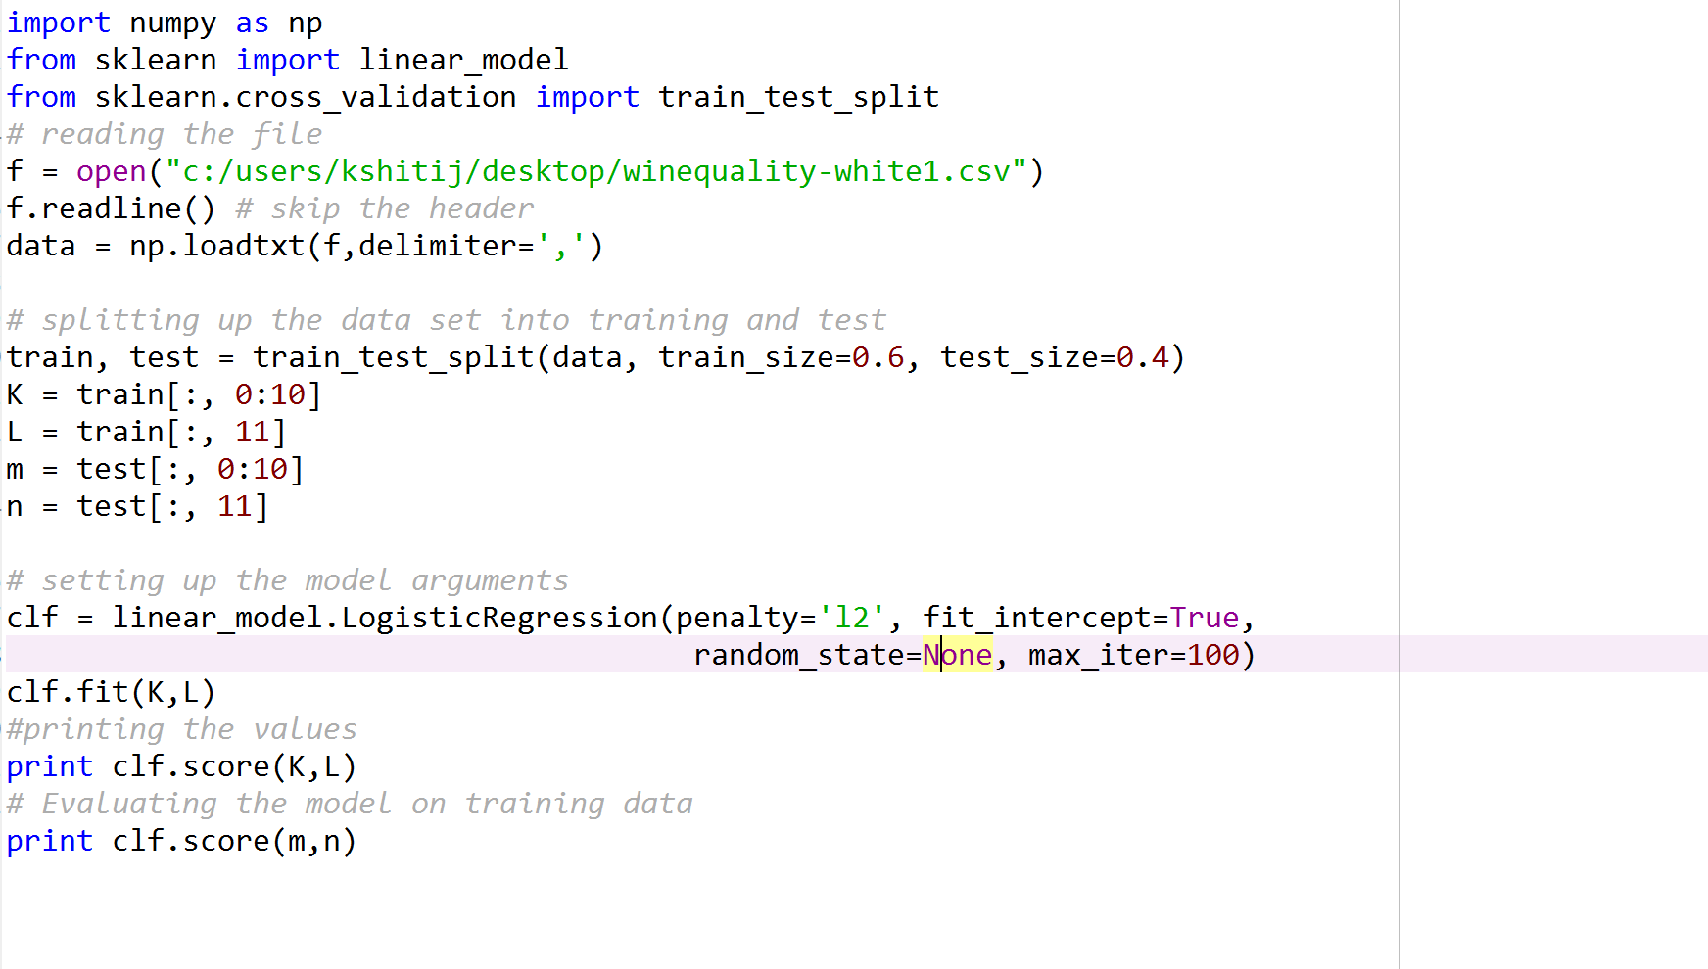

Regression Models

vii) Linear Regression Model

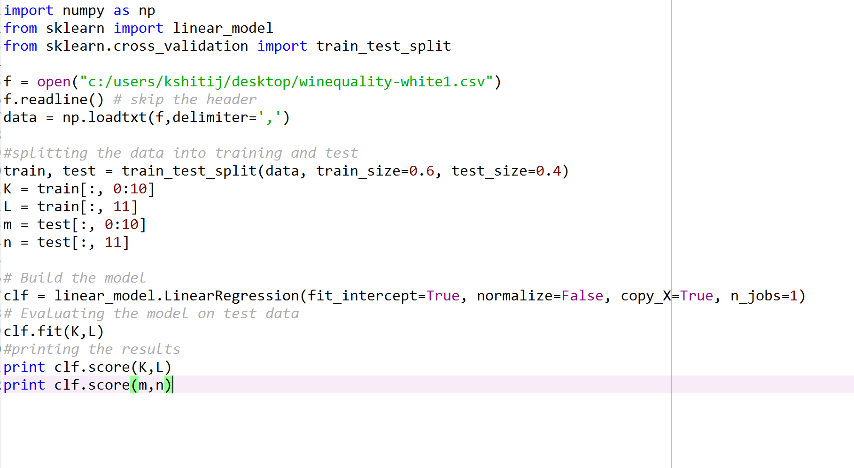

vii) SGD Regressor Model – L1 Regularization

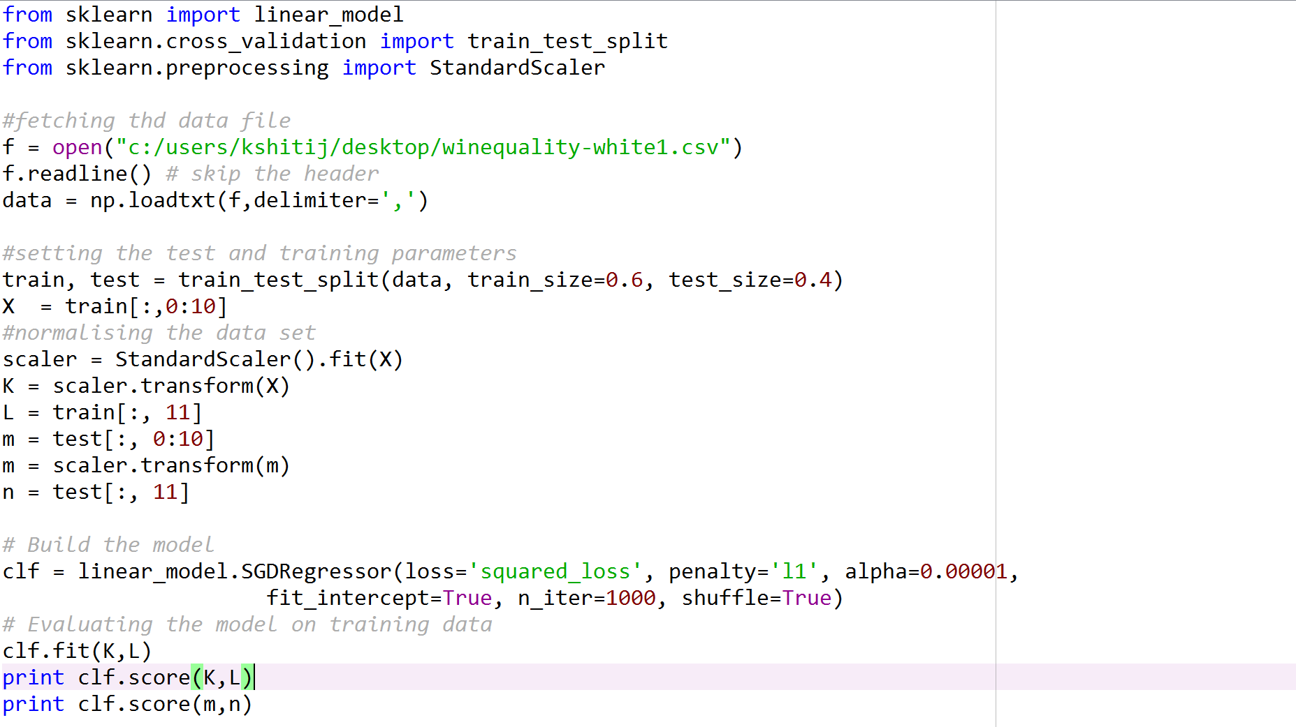

viii) SGD Regressor Model – L2 Regularization

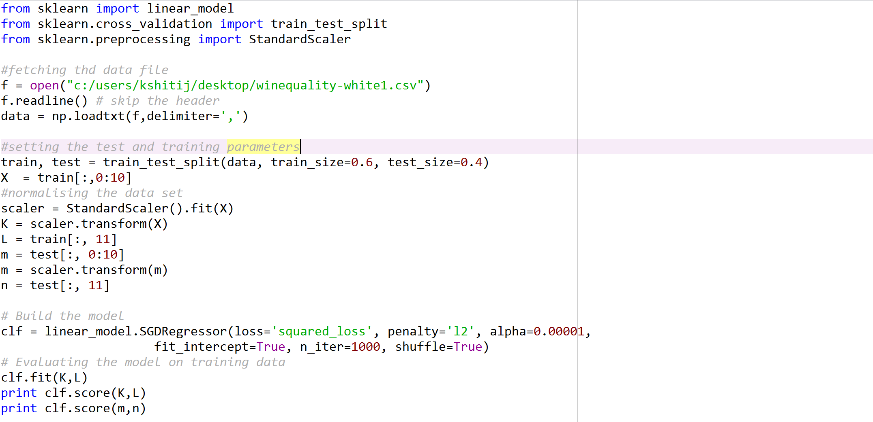

ix) Ridge Model

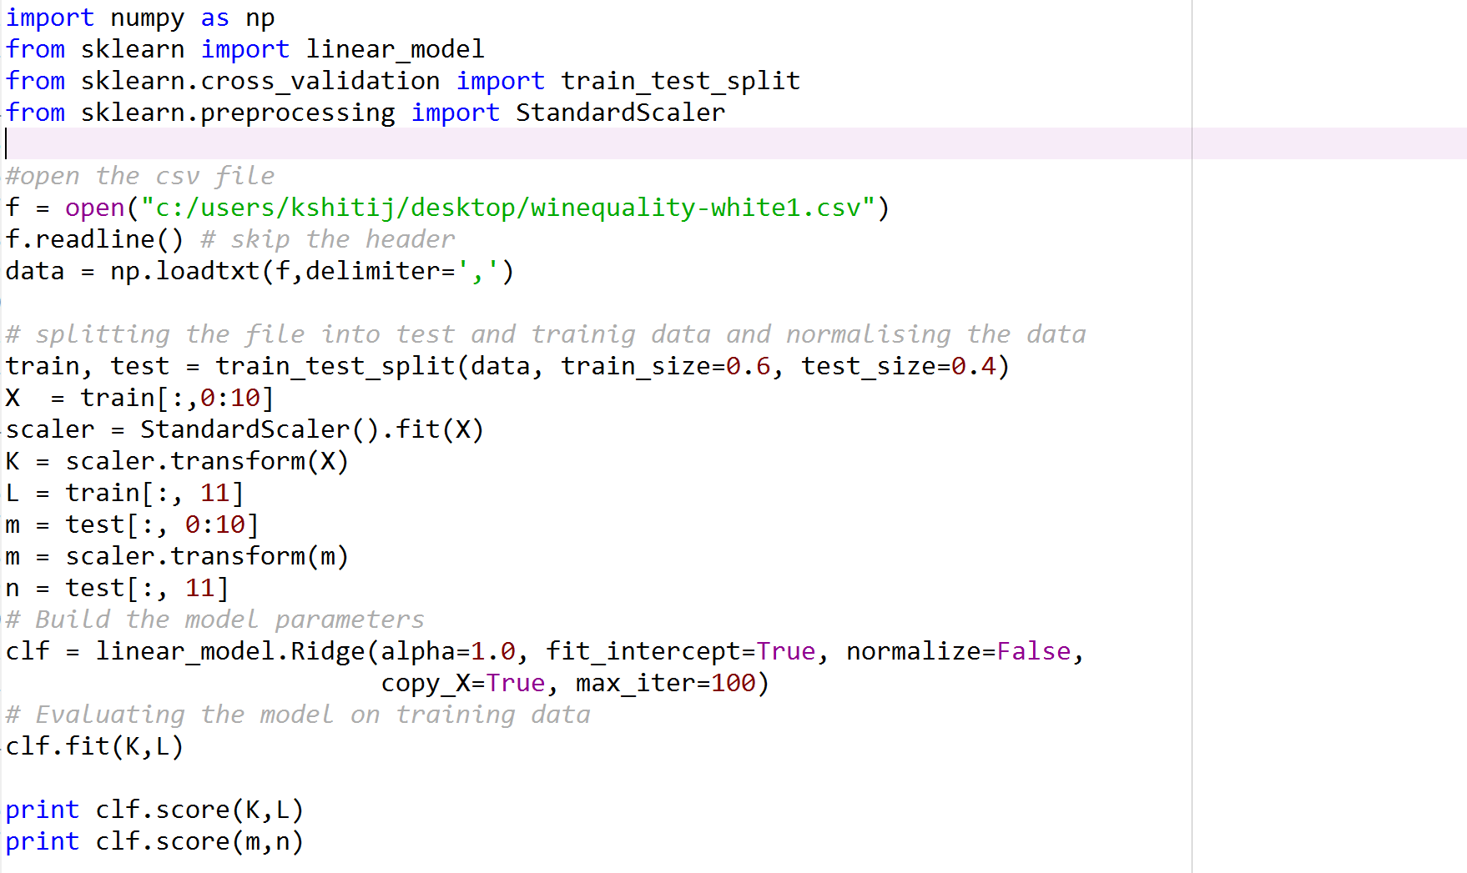

x) Lasso Model

## lasso

1. What performance metrics did you implement and use to evaluate Classification algorithms?

Parameters

Default : stepSize: 1.0, numIterations: 100, regParm: 0.01, miniBatchFraction: 1.0

When L1 regularization is not required, L-BFGS version is strongly recommended since it converges faster and more accurately compared to SGD.

Change in the number of iteration doesn’t impact the result much as the data is very small. However decrease in the step-size increase the accuracy of the result.

NOTE: if stepSize = 1 ; All Algorithms will give result NAN

|  |  |  |  |
| --- | --- | --- | --- |
| Algorithms Type | Parameters | Pyspark | Scala |
| SVMWithSGD | stepSize: .001, numIterations: 1000, regParm: 0.01, miniBatchFraction: 1.0  regType = “L1” | Training Error = 0.0367496937526 | Area under ROC = 0.6346782988004352 |
| stepSize: .001, numIterations: 100, regParm: 0.01, miniBatchFraction: 1.0  regType = “L1” | Training Error = 0.0367496937526 | Area under ROC = 0.5946580918004352 |
| stepSize: .001, numIterations: 1000, regParm: 0.01, miniBatchFraction: 1.0  regType = “L2” | Training Error = 0.0367496937526 | Area under ROC = 0.6327268553062039 |
|  | stepSize: .01, numIterations: 100, regParm: 0.01, miniBatchFraction: 1.0  regType = “L2” | Training Error = 0.0367496937526 | Area under ROC = 0.5946580918004352 |
| LogisticRegressionWithLBFGS | stepSize: .001, numIterations: 1000, regParm: 0.01, miniBatchFraction: 1.0  regType = “L1” | Training Error = 0.0367496937526 | Precision = 0.9605809128630706 |
| stepSize: .01, numIterations: 100, regParm: 0.01, miniBatchFraction: 1.0  regType = “L1” | Training Error = 0.0367496937526 | Precision = 0.9605809128630706 |
| stepSize: .001, numIterations: 1000, regParm: 0.01, miniBatchFraction: 1.0  regType = “L2” | Training Error = 0.0367496937526 | Precision = 0.9605809128630706 |
|  | stepSize: .01, numIterations: 100, regParm: 0.01, miniBatchFraction: 1.0  regType = “L2” | Training Error = 0.0367496937526 | Precision = 0.9605809128630706 |
| LogisticRegressionWithSGD | stepSize: .001, numIterations: 1000, regParm: 0.01, miniBatchFraction: 1.0  regType = “L1” | Training Error = 0.0367496937526 | Precision = 0.9600631403650002 |
| stepSize: .01, numIterations: 100, regParm: 0.01, miniBatchFraction: 1.0  regType = “L1” | Training Error = 0.0367496937526 | Precision = 0.9600631403650002 |
| stepSize: .001, numIterations: 1000, regParm: 0.01, miniBatchFraction: 1.0  regType = “L2” | Training Error = 0.0367496937526 | Precision = 0.9600622406639004 |
|  | stepSize: .01, numIterations: 100, regParm: 0.01, miniBatchFraction: 1.0  regType = “L2” | Training Error = 0.0367496937526 | Precision = 0.9600622406639004 |

Performance metrics (In Python)– Performance metrics – We tried to change various factors such as alpha, number of iterations and saw a significant change in the score value on changing alpha values

1. Linear SGD Classifier – Hinge Loss - Used L1 regularizes and Hinge Loss function

|  |  |
| --- | --- |
| alpha | score |
| 1 | .9592343456 |
| .5 | .9675455422 |
| .10 | .9689773636 |

Confusion metrics –

[[1872 26]

[ 61 0]]

1. Linear SGD Classifier – Hinge Loss - Used L2 regularizes and Hinge Loss function

|  |  |
| --- | --- |
| alpha | score |
| 1 | .9484565433 |
| .5 | .9657678655 |
| .10 | .9673478644 |

**confusion metrics below**

[[1867 13]

[ 76 3]]

1. Linear SGD Classifier – Hinge Loss - Used L1 regularizes and Log Loss function

|  |  |
| --- | --- |
| alpha | score |
| 1 | .9557673899 |
| .5 | .9584738902 |
| .10 | .9679877653 |

1. Linear SGD Classifier – Hinge Loss - Used L2 regularizes and Log Loss function

|  |  |
| --- | --- |
| alpha | Score |
| 1 | .9597867555 |
| .5 | .9639876567 |
| .10 | .9689878877 |

1. Logistic Regression Classification – L1 regularization

Tried different number of iteration, but does not seems to put any effect any effect in the score. Alpha was not a parameter for this algorithm.

Score = .9578656455

1. Logistic Regression Classification – L2 regularization

Tried different number of iteration, but does not seems to put any effect any effect in the score. Alpha was not a parameter for this algorithm.

Score = .969876765

1. What performance metrics did you implement and use to evaluate Regression algorithms?

Default : stepSize: 1.0, numIterations: 100, regParm: 0.01, miniBatchFraction: 1.0

When L1 regularization is not required, L-BFGS version is strongly recommended since it converges faster and more accurately compared to SGD.

Change in the number of iteration doesn’t impact the result much as the data is very small. However decrease in the step-size increase the accuracy of the result.

NOTE: if stepSize = 1 ; All Algorithms will give result NAN

|  |  |  |  |
| --- | --- | --- | --- |
| Algorithms Type | Various Parameter | PySpark | Scala |
| LinearRegressionWithSGD | stepSize: .01, numIterations: 100 | Mean Squared Error = 35.3340138832 | training Mean Squared Error = 6.751135104498063E5 |
| stepSize: .001, numIterations: 1000 | Mean Squared Error = 35.3340138832 | training Mean Squared Error = 6.751135104498063E5 |
| RidgeRegressionWithSGD | stepSize: .001, numIterations: 100  regType =”L2” | Mean Squared Error = 35.3340138832 | training Mean Squared Error = 4.8042799175778876351 |
| stepSize: .001, numIterations: 1000  regType =”L2” | Mean Squared Error = 35.3340138832 | training Mean Squared Error = 4.8042799175778876351 |
| LassoWithSGD | stepSize: .01, numIterations: 100  regType =”L1” | Mean Squared Error = 35.3340138832 | training Mean Squared Error = 1.4362289499005352052 |
| stepSize: .001, numIterations: 1000  regType =”L1” | Mean Squared Error = 35.3340138832 | training Mean Squared Error = 1.4362289499005352052 |

In Plain Python

1. Linear Regression

Tried normalizing the data to get more accurate value but does not put any effect on the accuracy.

Score = .03898675437

1. SGD Regression L1 Regularization – value drastically changes on changing the alpha value

|  |  |
| --- | --- |
| alpha | Score |
| .5 | -.002187874 |
| .1 | -.001023323 |
| .0001 | .0452376345 |

1. SGD Regression L2 Regularization – value drastically changes on changing the alpha value

|  |  |
| --- | --- |
| alpha | Score |
| .5 | -1.017956763 |
| .1 | -.0017467834 |
| .0001 | .0368796544 |

1. Lasso Model

|  |  |
| --- | --- |
| alpha | Score |
| 1 | -.0011236545 |
| .5 | -.0005456722 |
| .0001 | .0340986787 |

1. Ridge Model

|  |  |
| --- | --- |
| alpha | Score |
| 1 | .0427865775 |
| .5 | .0454434676 |
| .0001 | .0460987888 |

**Answer 4**

No doubt, Scipy has rich libraries than Apache Spark but lacks a lot in reveling a lot about the data, for example when we use the libraries for scipy we can found accuracy using score function which tells about how accurate the algorithm is working on predicting the data using the training data calculations.

With Apache Spark we have different calculation parameters which predicts the accuracy of the system such as Area under ROC, training errors etc.

**On performance factors** - Apache spark libraries are better for a lot of processing so when u have to dig the data deep in and figure out lot of computations Apache spark is better and comparing with scipy libraries they are not very useful for high processing work.

So, would prefer to use Apache Spark

**Easy Use** – Spark is built on scala so it is much easier to use its libraries and easy to understand as compared to scipy.

Classification

|  |  |  |
| --- | --- | --- |
| Classification | Scipy | Apache Spark |
| SGD ClassifierSVM | 0.961715160796 | 0.963250062474 |
| SGD Classifier Lograthmic Regression | 0.969372128637 | 0.969372128637 |
| Logistic Regression | 0.960183767228 | 0.969372128637 |

Regression

|  |  |  |
| --- | --- | --- |
| Regression Algos | Scipy | Apache Spark |
| Linear Regression | 0.0452406207707 | .94132634007 |
| SGD Regression | 0.0405330237698 | N/A |
| Ridge Model | 0.0381319185139 | .94132634007 |
| Lasso Model | 0.0253828576146 | .94132634007 |

As you can see from the above interpretation for classification Apache Spark seems to be slightly better in Classification. Whereas for the regression models Apache Spark is far better in the results.